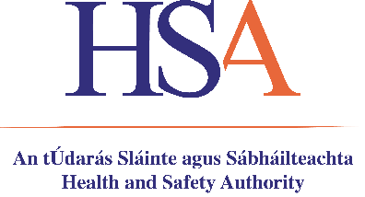

FORM OF NOTIFICATION FOR USE OF A GROUP 2, 3 OR 4 BIOLOGICAL AGENT*
As required under Regulation 14(1)(e) of the Safety, Health and Welfare at Work (Biological Agents) Regulations, 2013 and 2020 (S.I. No. 572 of 2013 as amended by S.I. No. 539 of 2020)

This form must be submitted to the Health and Safety Authority 30 days prior to the commencement of work involving the use for the first time of a group 2 or 3 or 4 biological agent or for the first time of each subsequent group 4 biological agent and any subsequent new group 3 biological agent, where the employer self classifies that biological agent.

For Office Use Only
Employer No. | Employer Place of Work No. (EPOW) | Correspondence No. | Date Received | Notification No.
Comments:

Section 1
For Notifier to complete
- Name of Company/Establishment
- Company Registration Number (CRO No) (if applicable)
- Address, Eircode & Telephone Number of
Company/Establishment

- Email address
- Address & Eircode of premises where the
biological agent will be stored or used
(if different to 3 above)

- Date of Notification | Click here to enter a date.
- Type of Notification | Choose an item.
 | (if ‘other’ chosen please state why or if re-notification state reasons why)
Section 2

- Type of Biological Agent being notified | Choose an item.
 | (If other please state)
- Species of biological agent

- Biological agent classification group | Choose an item.
- Name(s), qualifications and relevant experience of people responsible for safety and health at work

- Results of risk assessment (as required under Regulation 7 of the above Regulations)

- Protective and preventative measures envisaged

Name of Notifier

Position in Company/Establishment

Contact Telephone Number

Contact Email Address

Forms should be sent to:

- bioagents_notif@hsa.ie or
- Health & Safety Authority, Occupational Health and Hygiene Policy Unit, The Metropolitan Building, James Joyce Street, Dublin 1, D01 K0Y8.

*Classification of Biological Agents – Groups 2, 3 & 4

A "group 2 biological agent", means one that can cause human disease and might be a hazard to employees, although it is unlikely to spread to the community and in respect of which, there is usually effective prophylaxis or treatment available

A "group 3 biological agent" means one that can cause severe human disease and presents a serious hazard to employees and which may present a risk of spreading to the community, although there is usually effective prophylaxis or treatment available

A "group 4 biological agent" means one that causes severe human disease and is a serious hazard to employees and which may present a high risk of spreading to the community and in respect of which there is usually no effective prophylaxis or treatment available

Refer to Schedule 1 of the Code of Practice for the Safety, Health and Welfare at Work (Biological Agents) Regulations 2013 and 2020 (S.I. No. 572 of 2013 as amended by S.I. No. 539 of 2020) for current biological agents’ risk group classifications.

