Name of Product

**BRIGHT CLEANER**

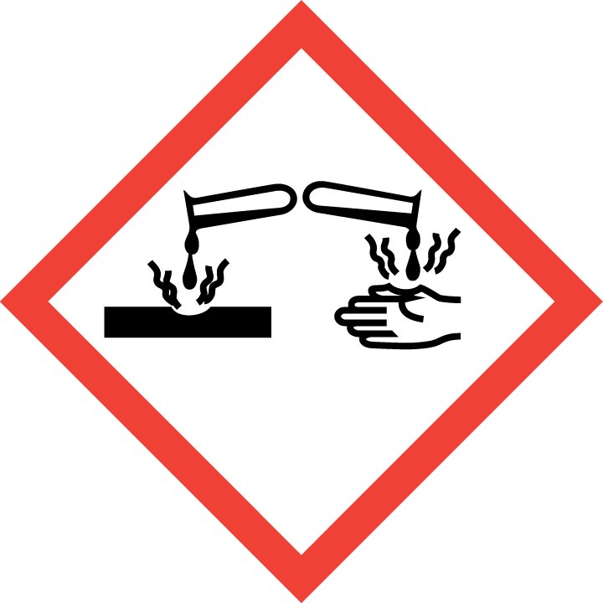

**Danger**

Causes serious eye damage

Causes skin irritation

Keep out of reach of children.

IF IN EYES: Rinse cautiously with water for several minutes

Wear protective gloves/protective clothing/eye protection/face protection.

IF ON SKIN: Wash with plenty of soap and water.

If skin irritation occurs get medical advice/attention.

Immediately call a POISON CENTRE or doctor/physician*.*

**1 Litre**

*1 Litre*

Bright Co. Ltd.,

Bright Lane,

Dublin 123.

Ireland.

Tel. no.: 00353 1 123 4567

E-mail: [brightbright@dot.com](mailto:brightbright@dot.com)

Ingredients list: [www.brightcleaningforever.com](http://www.brightcleaningforever.com)

Hazard Pictograms

Signal Word

Hazard statements

Supplier details/Tel. no./E-mail address for Ingredient Data Sheet and company website address

Precautionary Statements (max. of 6)

**Directions for use:** Dilute 150 ml of product with 2 litres of water. Apply to surfaces and leave for 20 minutes. Dry clean surfaces before rinsing treated surfaces with water.

and disposed according to national waste legislation requirements.

**Contains amongst other ingredients**:

15-30% Anionic surfactants, 5-15% Non-ionic surfactants,

< 5 % Phosphonates, Optical brighteners, Enzymes, Perfumes, Citronellol, Linalool,

Methylisothiazolinone (MIT) 2.5 % w/w and chloromethylisothiazolinone (CMIT) 1.5 % w/w

Nominal quantity

**1 Litre**

Instructions for use

Specific labelling requirements for detergents including listing of enzymes, optical brighteners, perfumes, allergenic fragrances and preservative agents.