
Product Safety Recall
Date: 03.02.2026

Helmet Integrated Systems Ltd, T/A Gentex Europe, recalls Full Face Mask

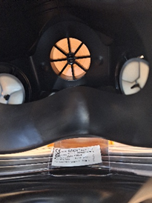
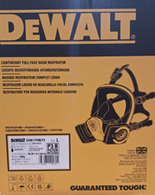
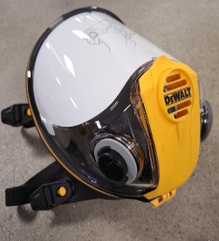

- Full Face Mask, sold with the brand DeWALT, Model 1600-008, with part number starting with “DXIRFFM”.
- The products with the batch numbers listed in the table below are affected. The batch number can be found on the label on the outer box (see second picture above) or inside of the Full Face Mask (see third picture above). Products outside these ranges are not affected.
Batch Numbers
0001/25 | 0003/29 | 0090003/42 | L011/44 | L2407/29 | L2411/46 | M050/12 | M050/40
0002/14 | 0003/40 | 2503/13 | L011/46 | L2408/32 | M0009/37 | M050/26 | M2409/38
0002/40 | 0010005/45 | L0009/36 | L050/01 | L2409/37 | M041/04 | M050/34 | M2411/45
0003/22 | 0090003/29 | L007/28 | L050/26 | L2410/40 | M050/01 | M050/36

- The product was sold from June 2023 to December 2025 through distributors and retailers in Belgium, Italy, Denmark, Poland, UK and Switzerland. EU-based distributors and retailers who sold this product include Scappin Group (Italy), Econex (Belgium), Safecare Nordic (Denmark), and Erpatech SP ZOO (Poland).

Why is this product dangerous?

- Cracking or breaking in the exhale valve area may affect the permeability of the mask, which could result in reduced respiratory protection.

What to do
- Stop using the product immediately.
- Return the product to the distributor from whom it was purchased for a replacement or refund.

Remedies for consumers
- You will receive a replacement or a refund for the product you return.

Contact
- Distributors have been notified and are prepared to support returns. Contact Emma Brocklesby-Fletcher: gereturns@gentexcorp.eu.com

