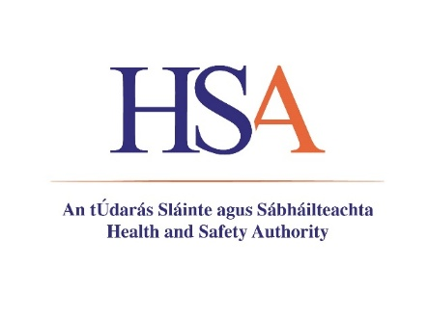
Application Form
OFFICE USE ONLY
Ref Number

- To apply for this role, visit www.hsa.ie/careers
- Applications should be submitted by email to recruitment@hsa.ie and must include:
- A CV and cover letter outlining why you wish to be considered for the role and why you believe your skills and experience meet the requirements of the role and;
- A completed comprehensive Application Form, clearly showing your relevant qualifications, achievements and experience in your career to date.
- Only applications fully submitted by email will be accepted into the campaign.
- Deadline for application: 2pm on Thursday 2nd April, 2026

Applicant Details
Applicant Name
Phone Number
Email

Employment History
Include most recent first – please include as an appendix to this application form any further employment history that you wish to add.
Employer Name
Employer Address
Position
Start Date
End Date
Brief Summary of role
(Max 200 words – please note only the first 200 words will be considered as part of the application)

Employer Name
Employer Address
Position
Start Date
End Date
Brief Summary of role
(Max 200 words – please note only the first 200 words will be considered as part of the application)

Employer Name
Employer Address
Position
Start Date
End Date
Brief Summary of role
(Max 200 words – please note only the first 200 words will be considered as part of the application)

Educational Qualifications and Training
Most recent first
Qualification | NFQ Level | Academic Institution | Major Subject | Dates of Study | Grade Obtained | Year Conferred

Education
Please confirm that you hold the below, if applicable:
First of Second class qualification to an Honour’s Degree (NFQ Level 8 or equivalent) in a relevant scientific or technical discipline to the role.
OR
First or Second class Higher Diploma (NFQ Level 8 or equivalent) in a relevant scientific or technical discipline to the role and a Primary Degree in any discipline (at least NFQ Level 7)
OR
Master’s Degree or a Post Graduate Diploma (NFQ Level 9) in in a relevant scientific or technical discipline to the role

Desirable
Relevant postgraduate/professional qualification relevant to the activities of the role

Evidence of Experience
For each of the criteria below, briefly describe what you consider to be a good example of demonstrating your ability in this area:

Essential Criteria

A minimum of 5 years' relevant professional experience (Max 300 words)

Strong Interpersonal and Communication skills (Max 300 words)

Evidence of proven negotiating and influencing skills (Max 300 words)

A proven track record at a senior level (within either the private or public sector) (Max 300 words)

Evidence of building and maintaining high performing teams. (Max 300 words)

Desirable Criteria

Work experience in a Government Department or within a regulatory body, working in the field of Chemical Legislation and/or experience in the European law (Max 300 words)

Current working knowledge of European Chemical legislation (Max 300 words)

Evidence of developing effective working relationships and providing robust and timely scientific and technical advices to aid effective decision making (Max 300 words)

General Information
The right to work within the European Union (EU) (Yes/No):

Do you hold and maintain a current Driving Licence valid for driving in Ireland (Yes/No)?

Are you proficient in the Irish language? (Yes/No)
Candidates who indicate that they are proficient may if called to final interview be required to undergo a test in order to verify their ability to communicate effectively in Irish.

Reasonable Accommodation
Candidates who indicate that they would like to avail of reasonable accommodations will be contacted directly by a member of our HR team, and may be asked to submit a medical report, the purpose of which is to provide information to act as a basis for determining reasonable accommodations where appropriate.
Please indicate whether you would like to avail of reasonable accommodations by ticking either Yes/No: | ☐ Yes | ☐ No

Referees
Minimum of two referees required related to your previous employment.
Name | Organisation and Position Held | Relationship to you | Contact Details
 |  |  | Email:
 |  |  | Email:
Do you require notification before your referees are contacted? (Yes/No):

Application Declaration
All information provided in this application is, to the best of my knowledge, true and correct. By submitting this application, I consent for the Health and Safety Authority to use my personal data contained in this application form for recruitment purposes. I understand that should any of the particulars furnished in this application be found to be false or misleading, it may lead to my application being rejected or, if I have already been appointed, to my dismissal. I also authorise the Health and Safety Authority to request copies of my academic transcripts and/or verify the authenticity of my qualifications with the academic institutions listed in Education Qualifications above.
Application submitted Electronically (Yes/No):
Signature
Print Name
Date of Submission

