Purpose:
Complete this template to assess how harmful chemical activities (vapour, fume, dust, gas, liquid) can cause harm before you use them. Identify actions to minimise potential harm to workers, others in the workplace and the environment. You should also use this form to reassess the chemical activity after an accident, near-miss, changes in workplace practices or chemical spill.
1. General information
Company name: |  | Risk assessor name:
Assessment date: | Click or tap to enter a date. | Work activity being risk assessed:
Chemicals used or generated in this activity (brand, mixture, substance): |  | -1
 |  | -2
 |  | -3
Next review date: | Click or tap to enter a date.

2. Details of work activity
Give details of how the hazardous chemicals are being used in this activity.
How are the chemicals used:  (for example, mixing of paints and spraying) |  | Staff carrying out the work:  (consider trainees)
Number of times per day or week this  work activity happens (frequency): |  | Number of people who might be harmed  or exposed: | Staff:
 |  | Number of people who might be harmed  or exposed: | Non-staff:
Length of time the work activity takes  each time (duration): |  | Any additional information:

3. Specific chemical information
Use your chemical inventory and Safety Data Sheets (SDS) provided by your supplier to assist you in filling out the table below for the chemicals in this activity.
Hazard pictograms (SDS section 2.2)  (Tick all that apply to this activity) | 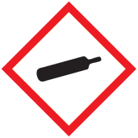 | 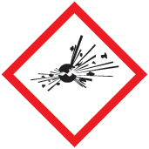 |  | 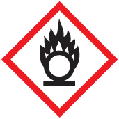 |  | 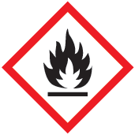 | 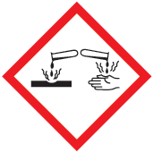
 | ☐ | ☐ |  | ☐ |  | ☐ | ☐
 | 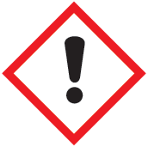 | 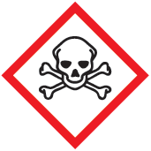 |  | 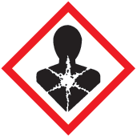 |  | 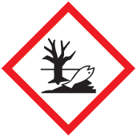
 | ☐ | ☐ |  | ☐ |  | ☐
Hazard statements: (SDS section 2)DS section 2)
(For example,
- H225: Highly flammable liquid and vapour.
- H301: Toxic if swallowed.
- H400: Very toxic to aquatic life.)
Cat 1A or 1B Carcinogenic, Mutagenic or Reprotoxic (CMRS) (SDS section 2) | Carcinogenic. ☐ |  |  |  | 1A ☐ 1B ☐
 | Mutagenic. ☐ |  |  |  | 1A ☐ 1B ☐
 | Reprotoxic ☐ |  |  |  | 1A ☐ 1B ☐
Recommended handling and storage precautions: (SDS section 7)  (Include specific details of your workplace, such  as quantity and storage location of the chemical  in the workplace). | Handling:
 | Storage:

4a. Activity-specific control measures in place
Look at the SDS for recommendations on the safe use, storage, handling, and PPE (Personal Protective Equipment) for the chemicals you are using in this activity. Record the specific control measures you have in place to reduce the likelihood of harm.
Control type | Control details
The least harmful chemicals are used: | Yes ☐ No ☐ Provide details: Click or tap here to enter text.
Route of exposure: | Breathing in (Inhalation) ☐ Skin (Dermal) ☐ Swallowing (Ingestion) ☐ Injection ☐
Engineering controls in place: | Natural ventilation ☐ Mechanical ventilation ☐ Fume hood ☐ Local exhaust ventilation ☐  M or H class vacuum ☐ Enclosure or containment ☐ Other: Click or tap here to enter text.
Engineering controls are maintained:  (for example, filters changed) | Yes ☐ No ☐
Administrative controls in place: | Staff training ☐ Task rotation ☐ Restricted access ☐ Housekeeping ☐ Safety signage ☐  Standard operating procedures ☐ Other: Click or tap here to enter text.
Training required:
Fire safety precautions in place:
(Include specific details of your workplace, for example, a flameproof cabinet in the workshop).
ATEX risk assessment required: | Yes ☐ No ☐
Welfare facilities in place:
(For example, hand-wash basins, with
warm water, changing rooms, canteen).
Emergency plans in place:  (Reference where the emergency plans  are available) | Fire and equipment ☐ Accidental mixing ☐ Spillages and kit ☐ First aid ☐  Other: Click or tap here to enter text.
First aid measures in place:  (Include locations) | First aid box or kit ☐ Chemical Shower ☐  Eye wash station ☐  Other: Click or tap here to enter text. | Locations: Click or tap here to enter text.
Measures in place to prevent accidental mixing of incompatible chemicals:
PPE in use:  (Take into account the risk of accidental mixing, which might create a new chemical needing specific PPE) | Safety glasses or goggles ☐ Gloves ☐ Respiratory Protective Equipment (RPE) ☐ Overalls ☐  Other: Click or tap here to enter text.
Type of PPE in use:
(For example, type, material, EN standard)
Respiratory Protective Equipment (RPE) in use:  (List the exact type, filter used, EN standard and ensure that the filter is appropriate for all chemicals used in the work activity) | Disposable ☐ Half-face ☐ Full-face ☐  Hood ☐ Powered ☐ Air-fed ☐ | Filter type: Click or tap here to enter text.
Waste disposal procedures:
(Include details or reference your waste procedure document)

4b. CMR control measures
Complete this section if you are using carcinogenic, mutagenic or reprotoxic (CMR) chemicals, either category (cat.) 1A or 1B in this activity.
Control type | Control details
CMRs are only used because safer alternatives are not available: | Yes ☐ No ☐ Provide details: Click or tap here to enter text.
The least number of people are exposed to CMRs: | Provide details: Click or tap here to enter text.
The least amount of CMRs are stored and used: | Yes ☐ No ☐
An enclosed system is used: | Yes ☐ No ☐ Provide details: Click or tap here to enter text.
The work activity is designed to avoid or minimise the release of CMRs into the workplace: | Provide details: Click or tap here to enter text.
Extraction methods in place to capture CMRs at source: | Fume Hood ☐ Local exhaust ventilation ☐ M or H class vacuum ☐ Enclosure or containment ☐  Other: Click or tap here to enter text.
Extraction methods are maintained: | Yes ☐ No ☐
Health surveillance is in place: | Yes ☐ No ☐ Provide details: Click or tap here to enter text.
Employees have received information about the risks of using the CMRs: | Yes ☐ No ☐
CMR containers are clearly labelled with warning and hazard signs: | Yes ☐ No ☐

5. Risk rating
For each stage of the chemical activity (tables A-F below), identify where someone might get harmed, the risk rating for this and if more controls are needed to reduce the current risk. Refer to section 2 of the “Chemical Agents Risk Assessment Template Supporting Information” document for an example of a risk matrix that may be used.
A. Chemical storage:
When and where could harm happen? | Likelihood | Severity | Risk rating | Additional controls needed
1. | Select | Select | Select
2. | Select | Select | Select
B. Handling and use:
When and where could harm happen? | Likelihood | Severity | Risk rating | Additional controls needed
1. | Select | Select | Select
1. | Select | Select | Select
C. Decanting:
When and where could harm happen? | Likelihood | Severity | Risk rating | Additional controls needed
1. | Select | Select | Select
1. | Select | Select | Select
D. Spillage or leak:
When and where could harm happen? | Likelihood | Severity | Risk rating | Additional controls needed
1. | Select | Select | Select
1. | Select | Select | Select
E. Chemical waste disposal (spills and containers):
When and where could harm happen? | Likelihood | Severity | Risk rating | Additional controls needed
1. | Select | Select | Select
1. | Select | Select | Select
F. Other:
When and where could harm happen? | Likelihood | Severity | Risk rating | Additional controls needed
1. | Select | Select | Select
1. | Select | Select | Select

6. Action list
Where additional controls have been identified in tables A-F, complete the action plan below.
 | Details of additional controls | Person responsible | Due date | Date completed
1. |  |  | Click or tap to enter a date. | Click or tap to enter a date.
2. |  |  | Click or tap to enter a date. | Click or tap to enter a date.

